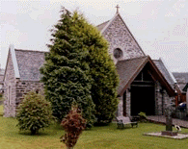

**ST. MARGARET'S PARISH**  
**Argyll Street, PA31 8NE**

**Parish Priest: Fr. Philip BUA**

**Tel. 01546 602380**

**Email: lochgilphead@rcdai.org.uk**

**Website: www.stmargaretslochgilphead.org**

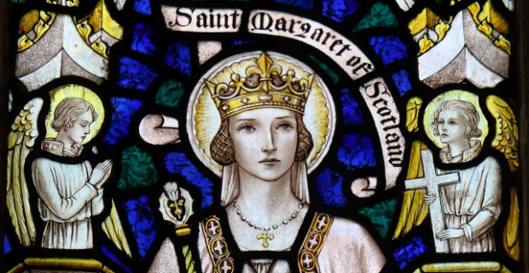

**Newsletter for the 18th Sunday in Ordinary Time Year B 4th August 2024**



**Welcome our Visitors:** A warm welcome to all our visitors to St. Margaret/ Inveraray Mass station. We are glad you worship with us today, may almighty God bless you all. Please, join us after Mass for Tea/Coffee. ***St. Margaret church,*** Tea/Coffee at the parish’s Tent outside the church. ***All Saints Inveraray*** Tea/Coffee at the back of the church after Mass. Our gratitude goes to the Hospitality group who made this possible, God bless you!

**Parish Council Meeting:**

The Parish Council Meeting is on the 7th of August in the tent at 6 pm. Parishioners are most welcome to send their suggestions for the council to discuss, email the priest or drop a note on the porch addressed to Fr. Philip, you don't need to include your name if you wish to.

**St. Margaret’s Garden:**

On Saturday 31st of August, Bishop Brian will bless our Parish Garden: Marian Grotto, Station of the Cross, and the fountain(Jesus, the Water of Life). Mass will be celebrated at 10:30 am by the Bishop in honour of our Blessed Virgin Mary and Blessing and dedication at 11 am. There will be refreshments (BBQ) afterwards. It would be great to see all parishioners present, this is our event and people from different places across the diocese and Scotland are coming for this event.

**Collections for last Sunday**

St. Margaret and All Saints Inveraray: Cash **£121.11**, Gift Aid **£132.50** Total: **£253.61**

**Led By the Spirit**

Phase 3 Resources and other materials to help us prepare for our parish meetings are available on the website,[www.ledbythespirit.rcdai.org.uk/phase-3/](http://www.ledbythespirit.rcdai.org.uk/phase-3/) visit it, take time to read and digest all the material to be found there, and most importantly pray for the grace to recognise you are called to holiness, asking to be open to whatever is required to answer this call.

**MOMA**

There are 3000 children living in poverty in Argyll & Bute. Some are here in Mid Argyll, even though at least one parent may be working. The school holidays are difficult. Could we make a special effort over the next few weeks to donate basics to Moving On Mid Argyll & help struggling families? Thank you as always for your continued support.

**Up Coming Events:**

* Parish Council Meeting is on 7th August.
* Blessing of the Garden: Grotto and Station of the Cross by Bishop Brian, 31st August followed by refrasement with our visitors from Taynuilt and Dunoon etc.

**SUNDAY HYMNS**

**Entrance 307.** Guide Me O Thy Great Redeemer.

**Offertory 175.** Blest are you Lord.

**Communion 349.** I Am the Bread of Life.

**Recessional 500.** O Bread of Heaven.

**Sunday Mass:   
St Margaret’s: 10 am  
All Saints, Inveraray, 12: 30  
(Taynuilt Parish Mass: 4 pm)**

**Weekdays Mass  
 St Margaret’s Church:**

**Tuesday 10:30 am**

**Wednesday 5-6 pm**Adoration of the Holy Eucharist

(Taynuilt Parish Mass: 10:30am)

**Thursday 10:30 am**

**Friday 10:30 am** Exposition of the Holy Eucharist   
at 10 am before Mass

**Saturday 10:30 am**

**Confessions   
from Tuesday to Saturday   
9:00 am – 9:40 am**before Mass and on request

**Please use the QR code below to make donations to the parish.**

**SCHEDULE   
THIS WEEK**

**Season of Creation Conference 2024**  
The Care of Creation Office of the Bishops’ Conference has organised a National Conference for this year’s Season of Creation which runs from 1st September – 4th October 2024. The Conference will take place on Saturday 7th September 2024, from 10am – 3pm in St. Margaret’s Parish Hall, Raploch, Stirling. The guest speaker is Ben Wilson, Director of Public Engagement for SCIAF. If interested in attending, please complete a booking form here [www.tinyurl.com/46wmt9ah](https://gbr01.safelinks.protection.outlook.com/?url=http%3A%2F%2Fwww.tinyurl.com%2F46wmt9ah&data=05%7C02%7Clochgilphead%40rcdai.org.uk%7C2dc97cd4e2424596238e08dca19aee83%7C488e337327604026b275c1d06c87e29c%7C0%7C0%7C638562934068681955%7CUnknown%7CTWFpbGZsb3d8eyJWIjoiMC4wLjAwMDAiLCJQIjoiV2luMzIiLCJBTiI6Ik1haWwiLCJXVCI6Mn0%3D%7C60000%7C%7C%7C&sdata=uBd4Ij0s3A3xDtYI6Oki457%2BQ9UxpYlNVfsf2bM93Fg%3D&reserved=0) and more details about this free day will follow.

**“What must we do, to be doing the works of God?”**

The question that the crowd asks Jesus: “What must we do, to be doing the works of God?” It is as if the people, provoked by Jesus, were saying: “How can we purify our search for God? How do we go from a magical faith, which thinks only of our own needs, to a faith that pleases God?” And Jesus shows the way: He answers that the work of God is to welcome the One whom the Father has sent, that is, welcoming Himself, Jesus. It is not adding religious practices or observing special precepts; it is welcoming Jesus, it is welcoming Him into our lives, living a story of love with Jesus. It is He who will purify our faith. We are not able to do this on our own. But the Lord wants a loving relationship with us: before the things we receive and do, there is Him to love. There is a relationship with Him that goes beyond the logic of interest and calculation.

This applies to God, but it also applies to our human and social relationships: when we seek first and foremost the satisfaction of our needs, we risk using people and exploiting situations for our own ends. How many times have we heard it said of someone; “But he uses people and then forgets about them”? Using people for one’s own gain: this is bad. And a society that puts interests instead of people at its centre is a society that does not generate life. The Gospel’s invitation is this: rather than being concerned only with the material bread that feeds us, let us welcome Jesus as the bread of life and, starting out from our friendship with Him, learn to love each other. Freely and without calculation. Love given freely and without calculation, without using people, freely, with generosity, with magnanimity.

Let us now pray to the Holy Virgin, She who lived the most beautiful story of love with God, that she may give us the grace to open ourselves to the encounter with her Son. ( *Pope Francis*)

**REFLECTIONS**